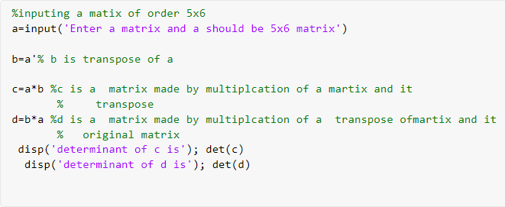15)

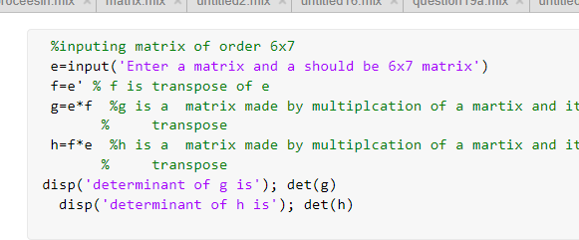

# OUTPUT

%inputing a matix of order 5x6

a=input('Enter a matrix and a should be 5x6 matrix')

|  |  |  |  |  |  |  |
| --- | --- | --- | --- | --- | --- | --- |
| a |  | | | | | |
|  | 1 | 2 | 3 | 4 | 5 | 6 |
|  | 2 | 5 | 8 | 6 | 4 | 5 |
|  | 7 | B | 9 | 4 | 5 | 6 |
|  | 4 | 5 | 6 | 1 | 2 | 3 |
|  | 7 | B | 4 | 2 | 0 | 3 |

b=a’% b is transpose of a

|  |  |  |  |  |  |
| --- | --- | --- | --- | --- | --- |
| b |  | | | | |
|  | 1 | 2 | 7 | 4 | 7 |
|  | 2 | 5 | 8 | 5 | 8 |
|  | 3 | 8 | 9 | 6 | 4 |
|  | 4 | 6 | 4 | 1 | 2 |
|  | 5 | 4 | 5 | 2 | 0 |
|  | 6 | 5 | 6 | 3 | 3 |

c=a*b %c is a matrix made by multiplcation of a martix and it



|  |  |  |  |  |
| --- | --- | --- | --- | --- |
| 91 | UB | 127 | 6fl | 61 |
| 110 | 17B | 208 | 110 | 113 |
| 127 | 20B | 271 | 154 | 175 |
| 64 | HB | 154 | 91 | 103 |
| 61 | US | 175 | 103 | 142 |

% transpose

d-b*a %d is a matrix made by multiplcation of a transpose ofmartix and it

|  |  |  |  |  |  |  |
| --- | --- | --- | --- | --- | --- | --- |
| d |  | | | | | |
|  | 119 | 144 | 134 | 62 | 56 | 91 |
|  | 144 | 182 | l8B | 91 | 8B | 124 |
|  | 134 | l8B | 2B6 | ]10 | 104 | 142 |
|  | 62 | 91 | 110 | 73 | 66 | 87 |
|  | 56 | 8B | 104 | 66 | 7B | 86 |
|  | 91 | 124 | 142 | 87 | 86 | 115 |

% original matrix disp(’determinant of c is'); det(c}

determinant of c is

ans = 17418 24

disp('determinant of d is’); det(d)

det erminant *of* d 1s ans = -1.2917e - B9



WINDOW

# OUTPUT

%inputing matrix of order 6x7

e=input('Enter a matrix and a should be 6x7 matrix’}

|  |  |  |  |  |  |  |
| --- | --- | --- | --- | --- | --- | --- |
| e |  |  |  |  |  |  |
|  | 1 | 2 | 3 | 4 | 5 | 6 |
|  | 2 | 5 | 8 | 6 | 4 | 5 |
|  | 7 | 8 | 9 | 4 | 5 | 6 |
|  | 7 | 8 | 4 | 3 | 0 | 3 |

f=e' % f is transpose of e

|  |  |  |  |  |  |
| --- | --- | --- | --- | --- | --- |
| f |  | | | | |
|  | I | 2 | 7 | 4 | 7 |
|  | 2 | 5 | 8 | 5 | 8 |
|  | 3 | 8 | 9 | 6 | 4 |
|  | 4 | 6 | 4 | l | 2 |
|  | 5 | 4 | 5 | 3 | 0 |
|  | 6 | 5 | 6 | 3 | 3 |

g=e*f %g is a matrix made by multiplcation of a martix and it

|  |  |  |  |  |
| --- | --- | --- | --- | --- |
| 91 | 11B | 127 | 64 | 61 |
| 116 | 17 B | 26B | 1IB | 113 |
| 127 | 2BB | 271 | 1 54 | 175 |
| 64 | UB | 154 | 91 | 103 |
| 61 | I]3 | 175 | ]03 | 142 |

% transpose

h=f"e %h is a matrix made by multiplcation of a martix and it

|  |  |  |  |  |  |  |
| --- | --- | --- | --- | --- | --- | --- |
| h |  | | | | | |
|  | 119 | 14d | 134 | 63 | 56 | 91 |
|  | 144 | 182 | 18B | 91 | 80 | 124 |
|  | 134 | 180 | 206 | *10 | 104 | 142 |
|  | 62 | 91 | HB | 73 | 66 | 87 |
|  | 56 | 80 | 104 | 66 | 70 | 86 |
|  | 91 | 124 | 142 | 87 | 86 | 115 |

% transpose disp('determinant of g is’); det(g)

de t enminant of g zs ans = 17418Z4

disp(' determinant of h is'); det(h)

de t enminant of h zs ans = -1.2917e -09



WINDOW

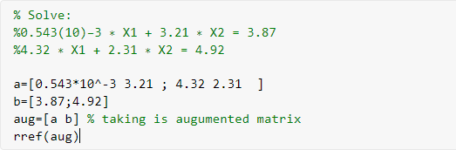16)



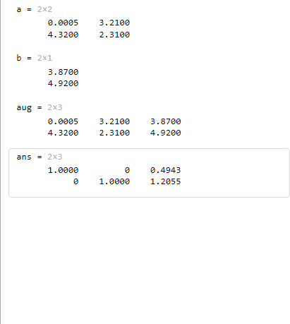

This is final

value of x and x2

So, x1=0.4943

and x2=1.2055

17)

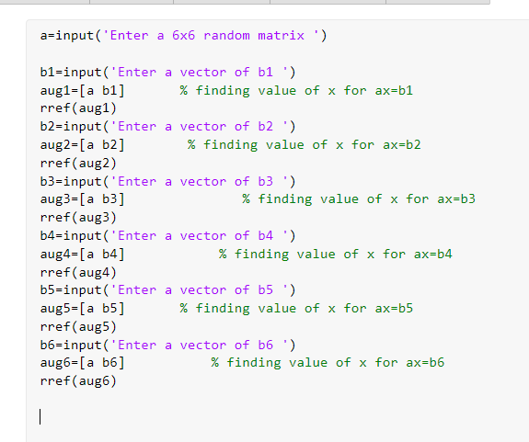



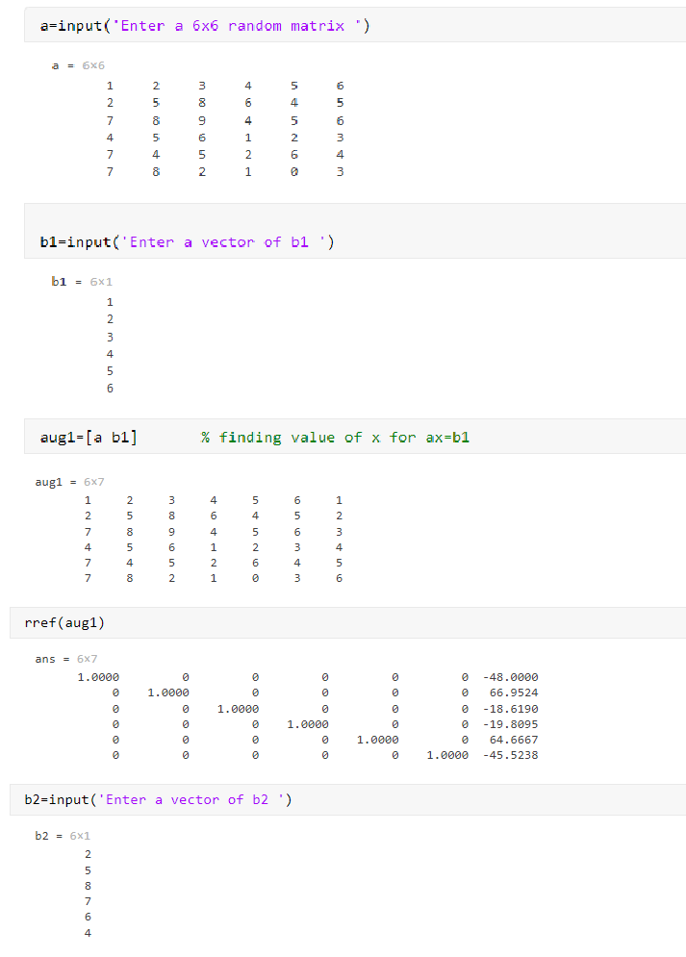

This is value of X for b1

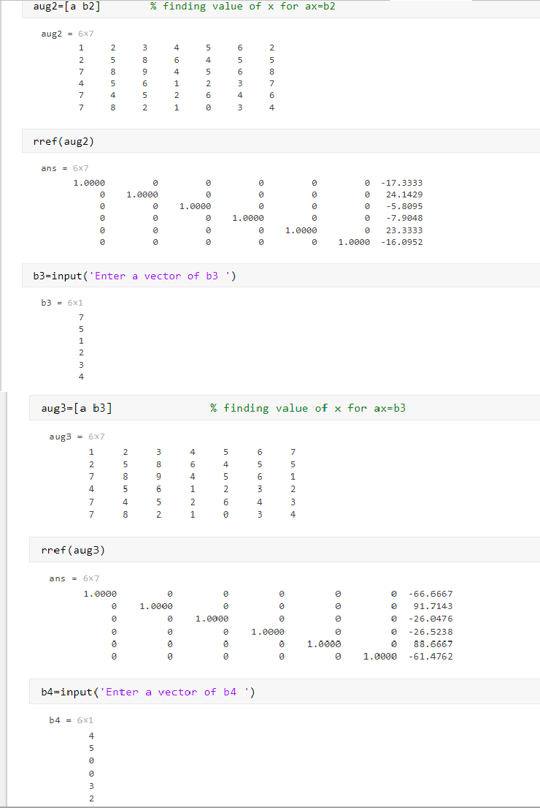

This is value of X for b2

This is value of X for b3

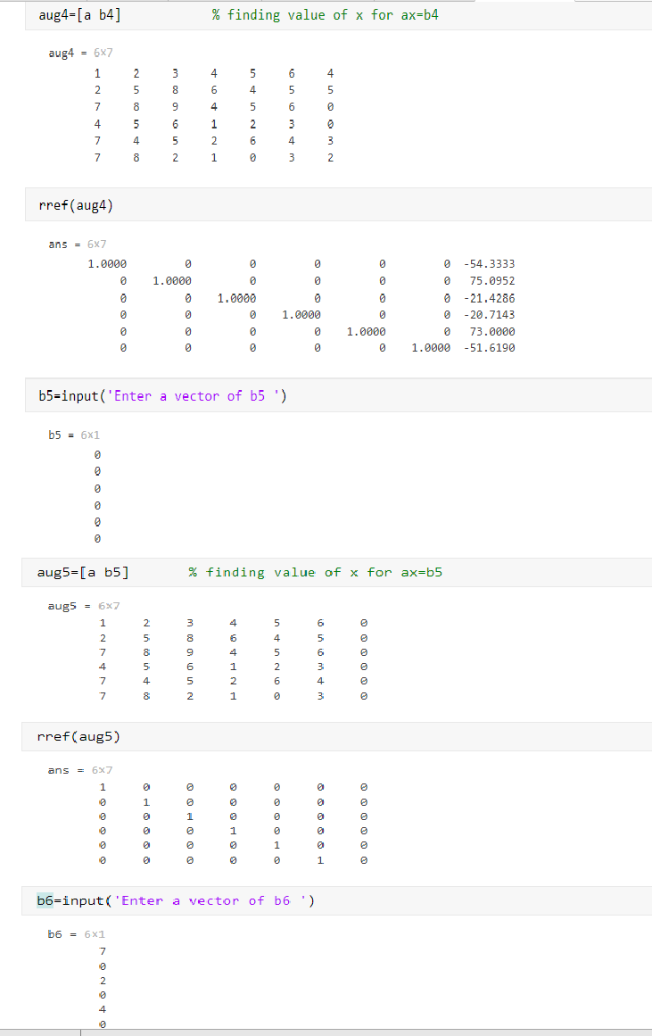

This is value of X for b4

This is value of X for b5

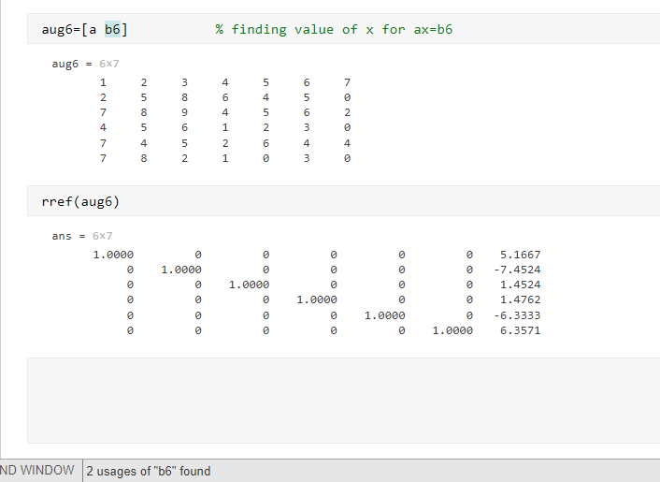

This is value of X for b6

18 )

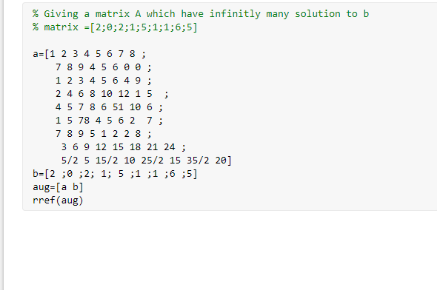



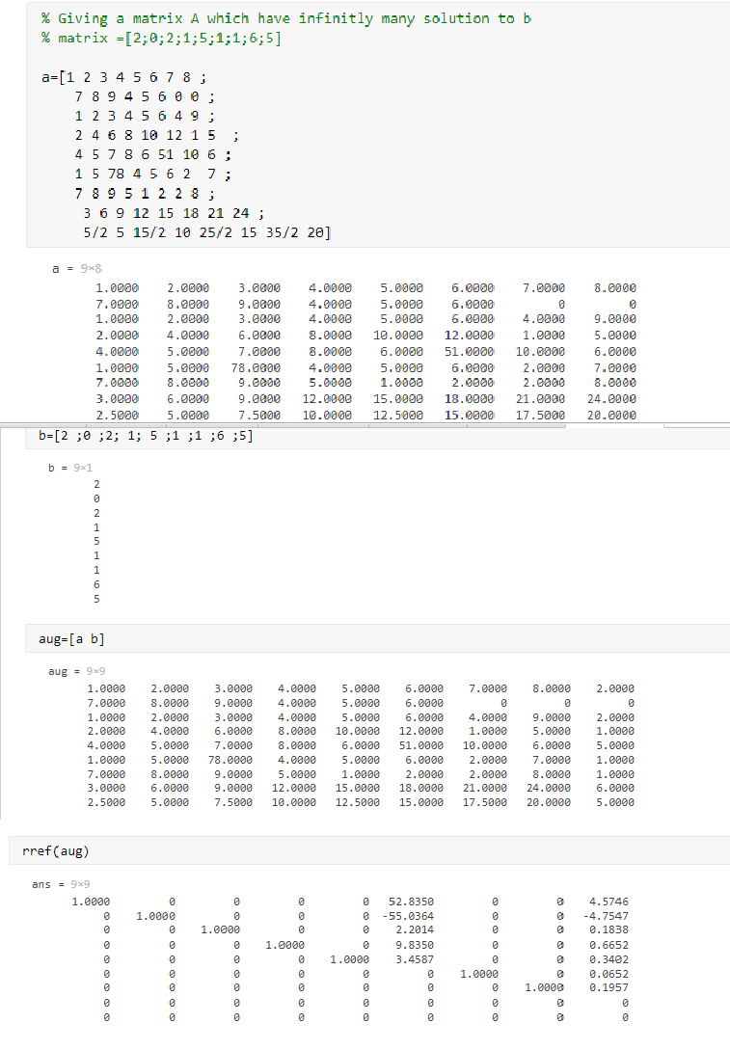

Since the augmented matrix 7 pivot entry . so,one free variable which is x6. So, infinitely many solution.

19)

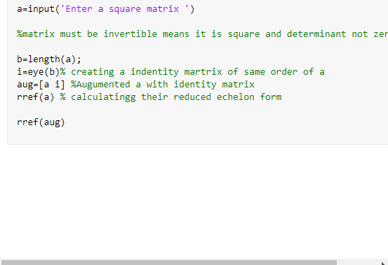



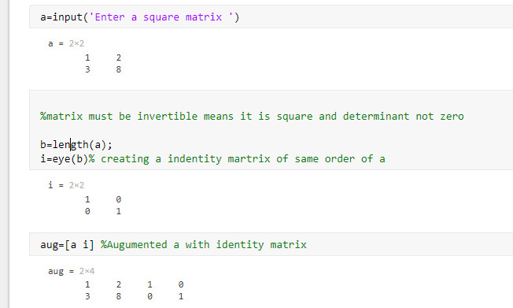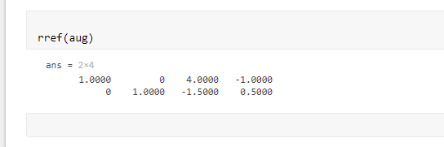

This is

inverse of a

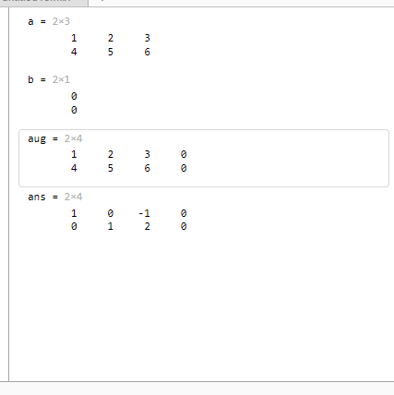20)

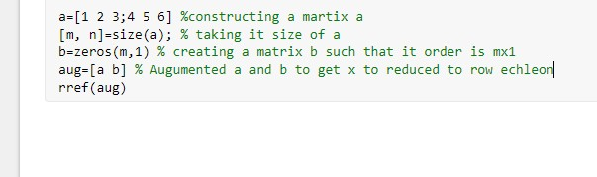

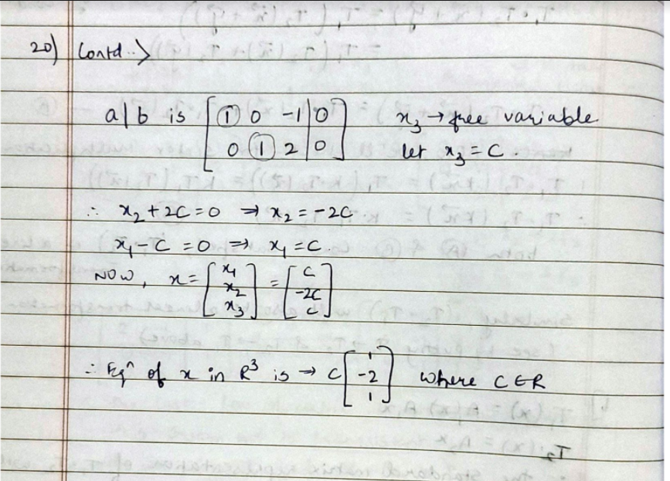

Thank you